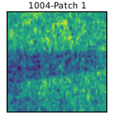
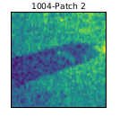
Decision network
ConvNet
Similarity
Patch 1
Patch 2

Underwater setup
Sonar images
captured
Patch generation algorithm
Labeled image
dataset with
bounding boxes
containing
object instances
Same object instances
Other object instances
Background instances
For each instance
10 matching pairs
10 Non-matching pairs
5 non-matching pairs
5 non-matching pairs
Total,
39840 pairs train
data, 7440 pairs
test data
Data generation algorithm
Labeled sonar
Images dataset with
bounding boxes
containing
object instances
Same object instances
Other object instances
Background instances
For each instance
10 matching pairs
10 Non-matching pairs
5 non-matching pairs
5 non-matching pairs
List of
matching and
non-matching
pairs

